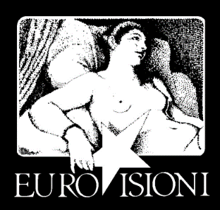
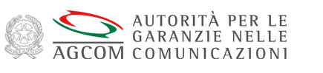

Giornata Internazionale / International Day
Venerdì 21 ottobre 2016 / Friday 21st of October 2016
Villa Medici, Accademia di Francia a Roma
Viale Trinità dei Monti 1, Roma
Seminario congiunto AGCOM ed Eurovisioni / Joint seminar AGCOM – Eurovisioni:
Le riforme dell’audiovisivo europeo: verso una posizione comune sulla Direttiva Servizi Media Audiovisivi (SMA), Copyright e Mercato Unico Digitale? / The European Audiovisual reforms: towards a common position on the Directive Audiovisual Media services (AVMS), Copyright and Digital Single Market?

9h00 Registrazione / Registration
9h30 Saluti iniziali / Welcome speeches
Villa Medici: Muriel Mayette Holtz
Eurovisioni: Michel Boyon
AGCOM: Antonio Martusciello
EBU: Guillaume Klossa

10h30 Panel 1: La revisione della Direttiva SMA tra tensioni istituzionali e di mercato / The review of the AVMS Directive: institutional and market pressures
The session aims at evaluating the European Commission’s proposal for a review of the AVMSD in the light of DSM goals, in particular, the proposed provisions on NRAs independence and the role of ERGA, the rules on the Country of origin principle and the new provision on video-sharing platforms will be discussed, as wee as the recent development of the legislative debate at EP and Council).

Moderatore / Chair: André Lange
AGCOM: Francesco Posteraro
CSA Schramek (*TBC)
Confindustria Radio Televisioni: Franco Siddi
DGMIC: Martin Ajdari
ERGA Madeleine De Cock Buning
Roma Tre: Fabio Bassan
Q & A

12h00 Panel 2: La diversità culturale e dei media in Europa nel nuovo ecosistema digitale / The diversity of culture and media in Europe in the new digital ecosystem
The diversity of culture and media is a pillar of Europe. It is important to discuss how to preserve it in the audiovisual field within the new digital ecosystem dynamics and to evaluate the suitability of the tools provided by the proposed AVMSD reform
Moderatore / Chair: Muriel Mayette Holtz (French Academy in Rome)
AGCOM: Antonio Nicita
APT Marco Follini
CSA: (*TBC)
FRANCE TV: Francis Donnat
RADIO FRANCE Mathieu Gallet
RAI: Luca Milano
Q & A
[repas privé avec Mme Silvia Costa]

14h30 Panel 3: Il mercato dei Servizi Media Audiovisivi nel contesto del Mercato Unico Digitale/The audio-visual media services market within the big picture of the Digital Single Market strategy
Aim of the session is to take stock and assess the various policy and legislative actions taken by the European Commission within the framework of the DSM Strategy, their coordination an potential impact on the audiovisual sector (among others, in the field of AVMS; Geo-blocking; Copyright on line; electronic communications networks; e-commerce….)

AGCOM: Antonio Preto
EBU: Richard Burnley
E-media: Emilio Pucci
European Commission: Lorena Box Alonso
Google: Andrea Stazi
Università Bocconi: Oreste Pollicino

15h30 Conclusioni/ Conclusions
AGCOM: Angelo Marcello Cardani
EU Parliament: Silvia Costa
Eurovisioni: Michel Boyon
MiBACT (Ministry of culture): Nicola Borrelli

Responsabile comunicazione: Alessandra Lombardi 347 7589385 alexlomb@gmail.com

