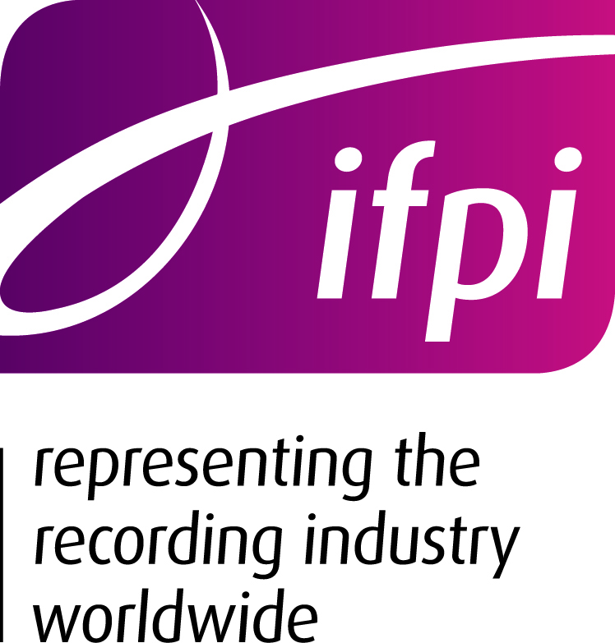
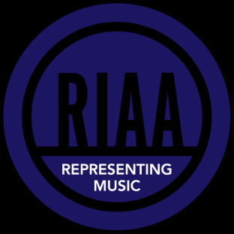

19th December 2011

One Year Later: Google’s Report Card on Making Copyright Work Better Online

In early December 2010, Kent Walker, General Counsel at Google, issued a blog post about Google’s commitment to work on developing new ways to make copyright work better online Google posted an update on its efforts in September. Below is an evaluation of each of Google’s specific commitments and an overall grade.

General Commitment

Promise: In that 2nd December 2010 blog, Mr. Walker stated: “We look forward to further refining and improving our processes in ways that help both rights holders and users.” In his 2nd September 2011 post, he reiterated this commitment, noting that Google “continue[s] to believe that making high-value content available in authorised forms is a crucial part of the battle against online infringement.”

Overall Grade: INCOMPLETE.
While Google has taken some modest steps to deal with copyright infringement online, the promises made by Google remain unfulfilled. Despite its steps, the simple fact is that Google continues to both (i) receive financial benefits from sites and applications that engage in piracy and (ii) place artificial road blocks in rights holders’ efforts to protect their content online, contrary to the DMCA.

In testimony before Congress earlier this year, Mr. Walker claimed that “Last year alone we invested US$60 million in efforts to prevent violations of our ad policies.” While that may seem like a large number, it has to be looked at in relation to Google’s revenues. That same year (2010), Google had revenues of more than US$29 billion, of which more than US$28 billion were derived from its advertising business. This “investment” in efforts to prevent violations represents only 2/10th of a percent of their revenues. Not such a big investment, after all.

We believe it is reasonable to expect Google to do more, particularly in those areas where Google financially benefits from the activity. Other intermediaries in the Internet ecosystem – such as payment processors, ISPs, and advertising firms – have all stepped forward to work constructively on voluntary initiatives to address rampant digital online theft and encourage the lawful consumption of creative works. Google, as the overwhelming market leader in search and online advertising, has a special responsibility to lead and create a safe and secure Internet experience that works for consumers and the creative community.

Specific Commitments

- Promise: Google will “act on reliable copyright takedown requests within 24 hours.”
- Status: More work needs to be done by a company built on its ability to respond to search requests within nanoseconds. Takedown times for pirate apps in the Android Marketplace, while improving, still take longer than 24 hours. More importantly, Google still doesn’t adequately screen apps before they are placed in the Android Marketplace. This means Google, by taking a “see no evil” approach, receives financial benefits from these pirate apps until such time as Google is notified and Google decides to take them down. And even then Google makes money from these apps to the extent Google continues its advertising or “Google wallet” relationship with those apps that have already been installed on devices. However, we do note that Google has improved its takedown speeds for links to infringing files in search results and on hosted blogs to less than 24 hours.

As it wasn’t all that long ago that Google required content owners to fax notices of infringement to the company, this is clearly an improvement. But in the area of pre-release material in particular, the damage that can be done in seconds, let alone days, cannot be overstated.

Moreover, this process isn’t meaningful when Google allows its users to issue counter notices simply by checking a few boxes on a form without having a clear understanding of the rights issues. Let us be clear - we agree that users with legitimate claims to the music at issue should be able to file counter notices. But we find it disturbing that Google admonishes rights holders to ensure their claim is valid and warns them about penalties for false claims, but fails to hold the average user to similar standards. Is that neutral, or is that tipping the scales in a manner that benefits Google’s bottom line?

- Promise: Google “will build tools to improve the submission process to make it easier for rights holders to submit DMCA takedown requests for Google products (starting with Blogger and web search).”
- Status: Rights holders remain unable to adequately address piracy on Blogger and web search through DMCA takedown requests because the tools Google has built have limits on the number of submissions rights holders can submit each day and they do not scale to the scope of piracy online.

- Promise: Google “will prevent terms that are closely associated with piracy from appearing in Autocomplete.”
- Status: Autocomplete still suggests terms associated with piracy when a user is searching for a piece of music or a movie. For example, when “lady gaga mp3” is typed into the search bar, autocomplete directs a user to choose “lady gaga mp3 free” or “lady gaga mp3 download,” results that lead to illegal sites. While Google has removed a few terms associated with piracy from autocomplete during a web search, more needs to be done.

- Promise: Google “will improve its AdSense anti-piracy review.”
- Status: Google, while making some efforts to remove infringing sites from its AdSense program, still needs to be more proactive in removing their advertising services from pirate sites, and in doing initial screenings of sites on which they serve ads to ensure they aren’t pirate sites. In cases like this where Google receives financial benefits from the activity in question, it is incumbent upon Google to review sites on which its serves ads before it places ads on its sites and to promptly take action once notice is received that the site engages in infringing activity. For example, we were disturbed to see that apps removed from the Android Marketplace for violating Google’s copyright policy nonetheless continued to have AdSense-served ads on them. We hope that this is being corrected. And we question why Google hasn’t extended its copyright policy commitment to its other advertising services, such as AdWords and DoubleClick – we think it should.

- Promise: Google “will experiment to make authorised preview content more readily accessible in search results,” and start “looking at ways to make authorised content easier to index and find.”
- Status: Google has persistently resisted requests by the music industry to prioritise sites with authorised content over unauthorised sites. We don’t understand why Google can’t take delisting notices for a site into account in determining rankings if it uses this information in its other copyright policy activities. And while we acknowledge that Google has launched Music Rich Snippets, Google did not meaningfully consult with music experts in developing the technological specifications to identify music for these purposes.

So What Can Google Do to Improve its Overall Grade? Stop Making Money From Digital Theft

In addition to the steps noted above, it would help if Google did the following:

Stop Advertising on Pirate Sites
Google should implement more reasonable, proactive steps to ensure that its ad services (AdSense, AdMob, and DoubleClick) do not place ads on Internet sites or applications that engage in infringement. While Google is improving its procedures to consider infringement notice information provided to it, Google should assure compliance by sites and applications with its terms of service that prohibit engaging in unlawful activity.

Stop Allowing Pirate Apps in the Google Store

1. Screening. Google should screen mobile applications, as Apple does, before allowing them to be made available in its Android Marketplace, to prevent pirate apps from being posted in the first place. Several of these apps, such as MP3 Music Downloader Pro, have Google-served ads embedded in the application. Given the financial benefit that Google receives from its Android app store and such in-app advertising, it is incumbent upon Google to ensure it is not supporting illegitimate activity. Google should not turn a blind eye to pirate apps, and then shift the burden to rights holders to identify them for take down, especially when they do not effectively prohibit repeat infringers (see below). Furthermore, Google has admitted that it does screen apps for Android compatibility purposes. Why won’t it do the same to screen for illegal activity?

2. Apps Designed or Known to Be Used to Facilitate Infringement. Google should take action on mobile apps available in its store that are designed to, or are known to be used to, offer unlawful content. Instead, often Google claims it “doesn’t know” that an app is used for infringing activity, even if public comments about the app – or even the app’s name itself – refer to or encourage such use. Google likewise argues that if an app theoretically can be used for any non-infringing use, even if it facilitates infringement, it should be able to be made available in Google’s store. This failure to take down such apps, even after it has received notice of such illegal activity and there has been widespread discussion of its use for illegal activity, has resulted in more than tens of millions downloads of the known pirate application MP3 Music Downloader Pro – and it’s still available on the Android Marketplace in new versions. This has a significant detrimental impact on the creators and owners of popular music, while providing a revenue stream for Google.

3. Stop Serving Ads or Providing Google Wallet Services on Apps Removed from the Marketplace, and if Appropriate, Terminate the Developer’s Account for these Services. Google has stated that one should “follow the money” with respect to the pirates. Yet, when Google removes an app from its Android Marketplace for violation of its copyright policies, it doesn’t necessarily stop providing Google AdSense or Google Wallet services to instances of that app previously downloaded. If we “follow the money,” we find that Google receives money from servicing these applications.

4. Repeat Infringers. Google should prohibit the posting of apps from developers who repeatedly have their apps taken down for violation of Google’s polices, and also for those whose accounts have been terminated. There are strong indicators that the same developer, under the same or different account, is continuing to post apps that facilitate infringement. It is disingenuous for Google to say it is taking efforts to stop infringing apps when it continues to permit developers to post in parallel, or subsequently repost, virtually the same app that has been taken down without consequences.

Prioritise Legal Search Results First
Sites that engage in infringing activity should not appear as the first results when searching for what entertainment content to download or stream. This just leads to more piracy and popularity of the site. Rather, whether a site is authorised or unauthorised to make copyrighted works available to the public should be a significant indicator in determining ranking of the result, with unauthorised sites having lower rankings than authorised sites.

Allow Copyright Holders to Search for Piracy in a Meaningful Way
Google continues to place artificial barriers on copyright holders’ abilities to effectively monitor for search listings to sites that facilitate infringement, making it hard to deal with piracy at a scale commensurate with the scope of the problem. For example, Google has a limit on the number of URLs that can be submitted via web search that is significantly smaller than the scope of the piracy problem. Google should remove such barriers in its web search tools. Google should also provide tools or access to content owners that operate at the same scale that Google allows content to be added to their systems. If not, then Google is condemning the content industry to fall further and further behind in dealing with infringing activity.

Prohibit Activity on YouTube that Induces Infringement
Increasingly, music-oriented videos posted on YouTube include links to download the sound recording associated with the video illegally. This is in violation of YouTube’s own policies. In addition, YouTube hosts videos explaining how to “game” the Content ID system and how to rip the audio content to create an MP3 file from a music video.

Why So Many Complaints?
Google should investigate why it has such a high volume of complaints from copyright holders, and whether additional procedural or technical changes could be made to assure legal activity, thereby lessening complaints.

Stop the Self-Serving Alarmist Rhetoric and Engage in Constructive Dialogue
While professing to agree that copyright infringement is a serious problem that needs to be addressed, Google raises alarmist, self-serving criticism to any legislative proposal to deter or thwart rampant copyright infringement. Google should stop engaging in destructive rhetoric and come to the table with constructive proposals to address this problem.

